Oracle Database 11g

Database plays a major role for any application. There are different types of databases available in the market as open source. Here I’m working with Oracle database 11g version.

**How to Install Oracle 11g?**

The Installation process of Oracle Database so simple and very easy. As it is open source we can download it for free of cost.

To download Oracle 11g please follow the link below:

<http://www.oracle.com/technetwork/database/enterprise-edition/downloads/112010-win64soft-094461.html>

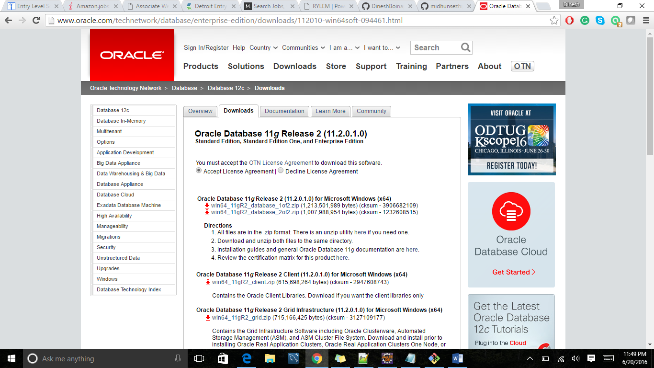

Please accept the Terms & Conditions and start downloading the two Zip files available on top.

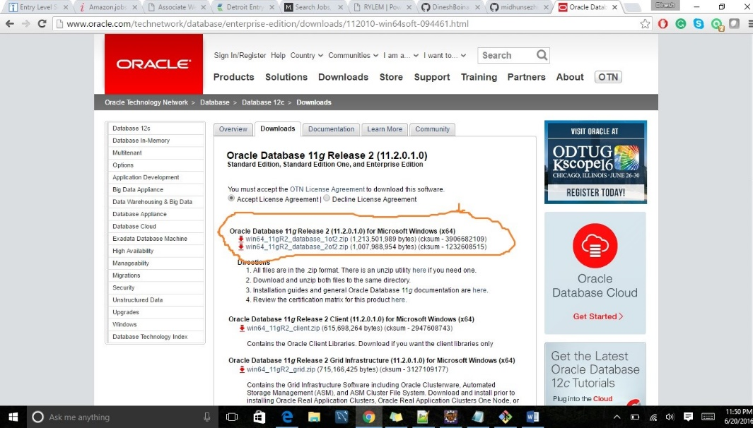

Once the downloading process is completed extract these two zip files and place these two extracted folders in one single folder.

* Now, please go into the zip file_2 and copy the files that are there in in folder 2 and paste them in zip file_1 in exact folder structure.
* By copying and pasting the files, the execution process will be easy and perfect manner.

By clicking the Installation Icon, it stats new window will pop up and starts installation process.

Please do mention and remember the username and password that is given during the installation process because by using these username and password in command prompt will allow the us to login into the Database. At the end before completion of installation process it shows one link that is “Manage Passwords”

Please click on this and go to the root and edit the password as tiger and confirm it. This is the end of Installation process.

Now, if we want to login into the Database and please enter “SQLPLUS”. And press enter. By doing this it will redirect to SQL and asks for Username and password. Please mention the user name and password which was provided during the Installation process. Even If we forget the username and password, we can still login into it by providing the username and password which we have edited during the manage passwords. i.e., username as “root” and password as “tiger”.